* **Assignment 2**
* **CSS (Cascading style sheets)**
* What are the benefits of using CSS?
* There are a number of benefits of CSS, including:

1) Faster Page Speed. More code means slower page speed. ...

2) Better User Experience. CSS not only makes web pages easy on the eye, it also allows for user-friendly formatting. ...

3) Quicker Development Time. ...

4) Easy Formatting Changes. ...

5) Compatibility Across Devic Disadvantages of CSS

Confusion due to many CSS levels. Beginners are more vulnerable to this issue. ...

Cross-Browser Issues. Different browsers work differently. ...

Security Issues. Security is important in today's world driven by technology and data. ...

Extra Work for Developers.es.

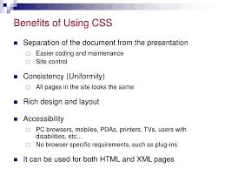

* What are the disadvantages of CSS?
* **Disadvantages of CSS**
* Confusion due to many CSS levels. Beginners are more vulnerable to this issue. ...
* Cross-Browser Issues. Different browsers work differently. ...
* Security Issues. Security is important in today's world driven by technology and data. ...
* Extra Work for Developers.

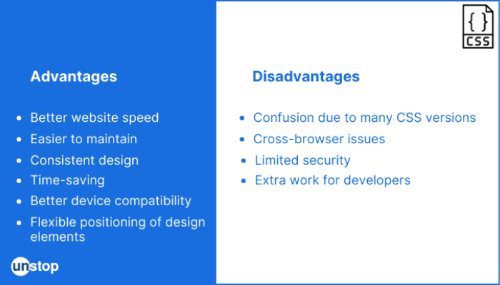

* What is the difference between CSS2 and CSS3?
* The biggest difference between CSS2 and CSS3 is that CSS3 is now split into different modules. Since each module makes its way through the W3C individually, there's a wider range of browser support. Make sure you test your CSS3 pages in as many browsers and operating systems as possible to ensure compatibility.

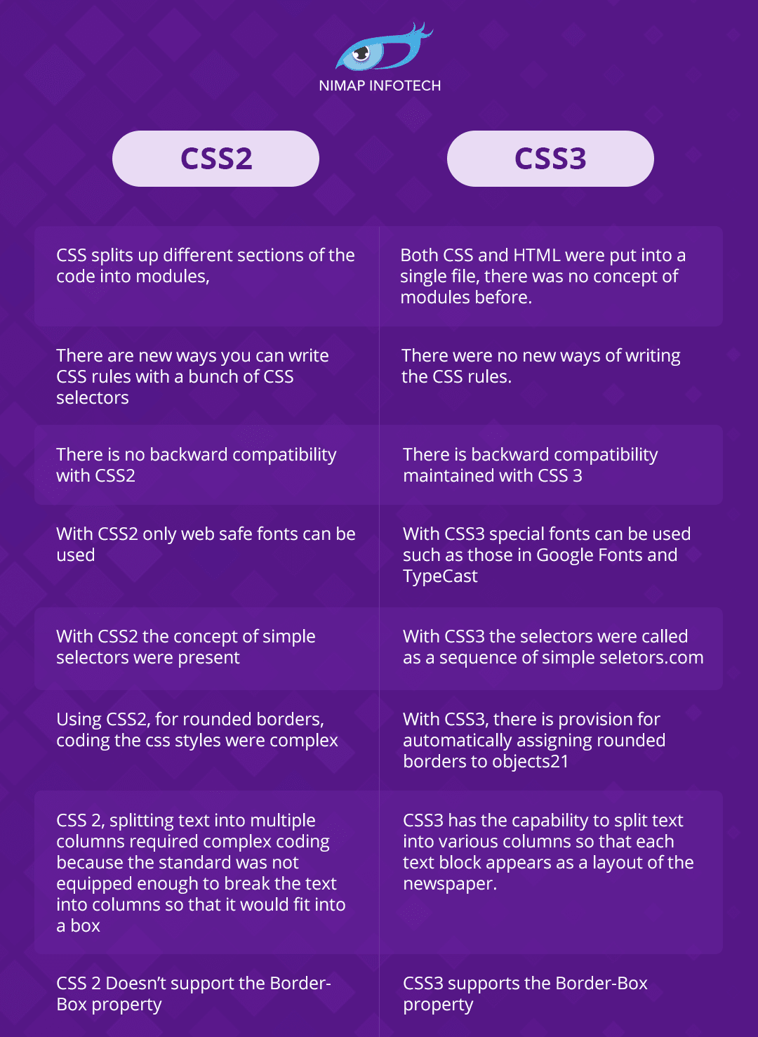

* Name a few CSS style components
* At its most basic level, CSS consists of two components:

Properties: These are human-readable identifiers that indicate which stylistic features you want to modify. For example, font-size , width , background-color .

Values: Each property is assigned a value. This value indicates how to style the property.

If I am understanding your question.

* Selector: class name, id name or element name that is target
* Attribute: name of the attribute you want to style for example border, color, background, position etc.
* Value of Property: value that will be assigned to attribute.

A typical CSS style will be like

1. p{
2. color:red;
3. position: relative;
4. text-align:left;
5. }

p is selector, following style rules will be applied to all paragraph.

color is attribute and value is red  
position is another attribute with value relative  
text-align is last attribute with value left.

* What do you understand by CSS opacity?
* The CSS opacity property is used to specify the transparency of an element. In simple word, you can say that it specifies the clarity of the image. In technical terms, Opacity is defined as degree in which light is allowed to travel through an object.

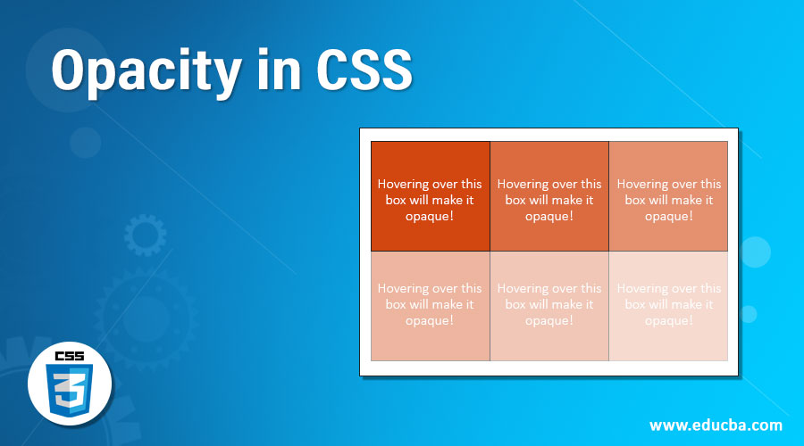

• How can the background color of an element be changed?

* To add background color in HTML, use the CSS background-color property. Set it to the color name or code you want and place it inside a style attribute. Then add this style attribute to an HTML element, like a table, heading, div, or span tag.

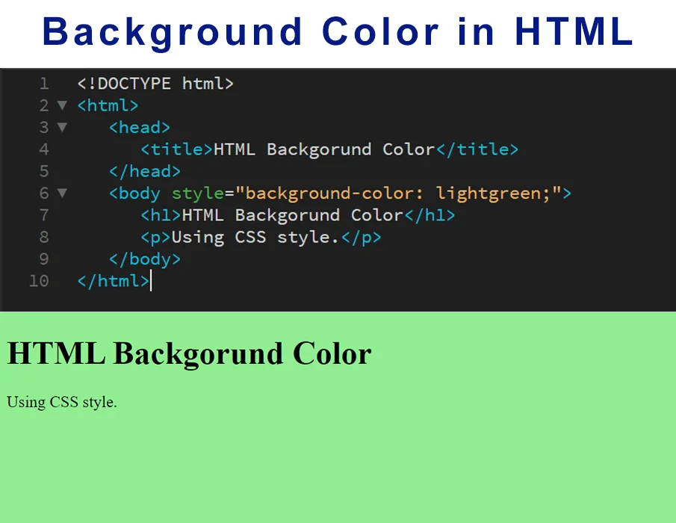

* How can image repetition of the backup be controlled?
* This task can be achieved by using the background-repeat property that will help us to control the repetition of the image. The background-repeat property in CSS is used to repeat the background image both horizontally and vertically. It also decides whether the background image will be repeated or not.

• What is the use of the background-position property?

* The background-position property sets the starting position of a background image. Tip: By default, a background-image is placed at the top-left corner of an element, and repeated both vertically and horizontally.

• Which property controls the image scroll in the background?

* The background-attachment property sets whether a background image scrolls with the rest of the page, or is fixed.
* Why should background and color be used as separate properties?
* There are two reasons behind this: It enhances the legibility of style sheets. The background property is a complex property in CSS, and if it is combined with color, the complexity will further increase.

• How to center block elements using CSS1?

* With css the way to center anything that's a block level element is with the margin property. One of the values of margin is auto and by setting auto on the left and right margin our block level element will center itself.

• How to maintain the CSS specifications?

* The Specification defines how CSS properties should be implemented by browser vendors along with detailed algorithms, code samples and tabular information. The Specification also include: The syntax and data types of the language. Detailed explanation on CSS Selectors.

• What are the ways to integrate CSS as a web page?

* CSS can be added to HTML documents in 3 ways: Inline - by using the style attribute inside HTML elements. Internal - by using a <style> element in the <head> section. External - by using a <link> element to link to an external CSS file.

• What is embedded style sheets?

* Embedded style sheets allow you to define styles for the whole HTML document in one place. Embedded style sheets refer to when you embed style sheet information into an HTML document using the <style> element. You do this by embedding the style sheet information within <style></style> tags in the head of your document.

• What are the external style sheets?

* An external style sheet is a separate CSS file that can be accessed by creating a link within the head section of the webpage. Multiple webpages can use the same link to access the stylesheet. The link to an external style sheet is placed within the head section of the page.

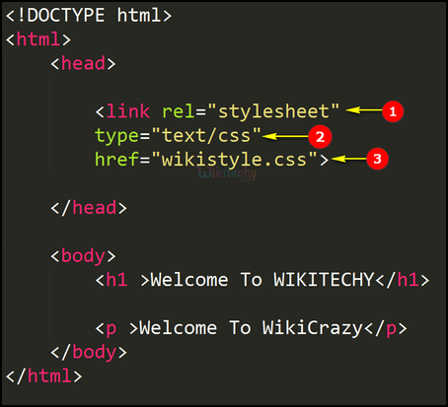

• What are the advantages and disadvantages of using external style sheets?

The advantages of External Style Sheets: With the help of External Style Sheets, the styles of numerous documents can be organized from one single file.

In External Style Sheets, Classes can be made for use on numerous HTML element types in many forms of the site.

In complex contexts, Methods like selector and grouping can be implemented to apply styles.

The disadvantages of External Style Sheets: An extra download is essential to import style information for each file.

The execution of the file may be deferred till the external style sheet is loaded.

While implementing style sheets, we need to test Web pages with multiple browsers in order to check compatibility issues.

• What is the meaning of the CSS selector?

* CSS selectors are used to "find" (or select) the HTML elements you want to style.

Types:

* Element selector
* Id selector
* Class selector
* Universal selector
* Multivalued selector

• What are the media types allowed by CSS?

* There are two ways to specify media dependencies for style sheets :
* Specify the target medium from a style sheet with the @media or @import at-rules.
* Specify the target medium within the document language.

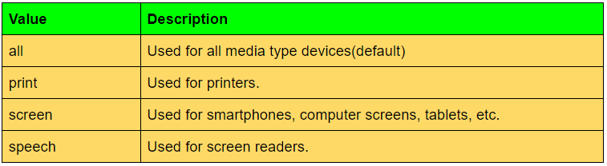

• What is the rule set?

* A CSS ruleset is various affirmations to various pieces or elements of the document.

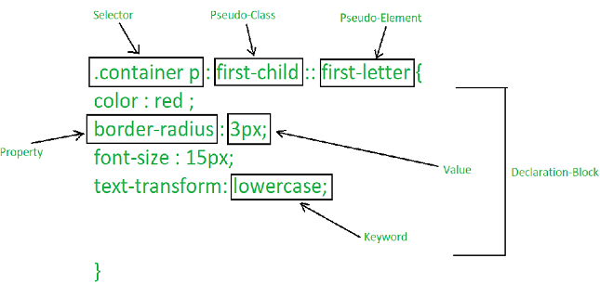

• Create Layouts

<file:///C:/Users/Sandeep/Desktop/trial/(thumbnail)css%20&%20css3%20assignment.html>

